PHASE 2:

Aerodynamic Characteristics
Using ADBSat to gather a single CD value to scale across altitude range:
- Telescope size and therefore satellite required size scales with altitude
  - Have to remodel for every altitude
  - Take 1 or a couple values
- Using a single design model how the drag changes with angle of attack + sideslip
  - Create Aerodynamic Database from this
- GSIM -> Using Sentman Model -> Accommodation coefficient of 1
  - Fully Diffuse
  - VLEO full of Highly Reactive Atomic Oxygen
  - Rapidly degrades surfaces
  - Most conservative baseline

Repeating Ground Track
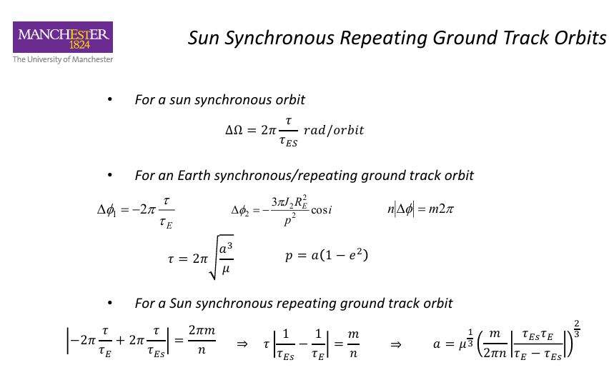
Ensures our SSO is able to complete the 5-day revisit time requirement.

Calculate Drag Force
Using the CD from ABDSat, we calculate drag:
$$F_{D}=\frac{1}{2}ρV^{2}C_{D}A_{Ref}$$
- The Area dynamically changes with aperture size and required solar panel size
- The CD value therefore is technically incorrect
- Add a margin to account for this
- Area used is based on nominal worst case scenario, the panels in worst position with the satellite facing the earth.
  - Cuboid: Aref = Bus + Solar Array
  - Cylindrical: Aref = Bus

Sizing the Fuel Tank
Counter force against drag:
$$T=F_{drag}$$
Required Impulse:
$$I_{tot}=T*∆t$$
Propellant Mass:
$$M_{prop}=\frac{I_{tot}}{I_{sp}*g}$$
$$=\frac{F_{drag} *∆t}{I_{sp}*g}$$
Power Requirements
Thruster Power Required:
$$P_{thrust}=\frac{T*I_{sp}*g}{2*η_{T}}$$
Total Power:
$$P_{total}=P_{bus}+P_{thrust}$$

Orbital Duty Cycle:
$$X_{sun}=1-(\frac{T_{eclipse}}{T_{orbit}})$$
This is the sunlight ratio
Therefore, Power generation required:
$$P_{req}=\frac{P_{total}}{X_{sun}}$$
Sizing the Solar Array
$$A_{sa}=\frac{P_{req}}{G_{s}*η_{sa}*η_{pack}*{\left(1-d\right)}^{L}}$$
Looped through and added to the Aref until convergence, at lower altitudes this should spiral out of control.
Thruster Sizing
Using the 5 different thruster types we will trade-off using the averages of values from the Electric Propulsion Lecture to gather how much power is needed, which forces the solar arrays which then gives us a wet mass value.
Dynamic Power System
Using SIMULINK, a dynamic power system is made to verify our battery charge state over orbits.
Advanced model uses atmospheric density to determine the power needed to be drawn from the thrusters. Some variables that are changed are listed below:
- F10.7A: 81-day average (three solar rotations) gives a baseline climate “background heat” of the atmosphere
- F10.7: Daily Solar Radio Flux gives the amount of radio noise the sun is emitting at wavelength of 10.7cm. Radiation physically heats the atmosphere causing expansion and changes in density.
- Ap: Geomagnetic Activity, Magnetism and Solar Wind. When sun exerts a Coronal Mass Ejection, it hits the Earths magnetic field and heats the atmosphere from the poles outward.
As 2026 is a Solar Maximum during Solar Cycle 25, Nominal baseline was picked for varying density:
F10.7: 150
F10.7A: 150
Ap: 15
The power load is also time-varying dependant on the payload being inactive during eclipse.

